An example of RS-fMRI data analysis using RESTplus
Participants. Thirty-four healthy control participants was included in the current study. All participants have no history of psychiatric disorders and neurological illness. Each paricipant has both eyes open (EO) and eyes closed (EC) sessions.The study were approved by the committee of the Center for Cognition and Brain Disorders, Hangzhou Normal University (HNU). All participants signed the informed consent of the study. More detailed information of participants can be found in (Zou et al., 2015).
Data acquisition. Using gradient echo EPI pulse sequence, the BOLD images were acquired (TR/TE = 2000/30ms, 37 slices, thickness/gap = 3.4.0mm, 240 time points). The structural image were acquired using a spoiled gradient-recalled pulse sequence (TR/TE = 8100/3.1ms, 176 slices, thickness = 1mm). More detailed information of parameters can be found in (Zou et al., 2015).
Data preprocessing. Data preprocessing was performed by pipeline module of RESTplus. For fMRI images, the 10 time points were excluded. The slice timing and realign were used to corrected temporal differences and head motion. Subjects whoes head motion were more than 1 mm or 1° were excluded in the following analysis. The functional data was normalized to Montreal Neurologic Institute (MNI) space by using T1 image unified segmentation. The smooth was performed by using an isotropic Gaussian kernel (6 mm full width at half maximum). The detrend was used for removing linear trend of the time series. Then the data were temproally bandpass filtered (0.01 ~ 0.08 Hz). For preprocessing, the filter step was not used for ALFF calculation and smooth step was not used for KCC-ReHo.
ALFF, PerAF and KCC-ReHo. RS-fMRI metrics were claculated by pipeline module of RESTplus. Fast Fourier transform (FFT) was used for ALFF calclulation (Zang et al., 2007). ALFF represents the strength of low frequency spontaneous activity (0.01 ~ 0.08 Hz). PerAF represents the percent signal change of BOLD signal at single voxel level (Jia et al., 2017). KCC-ReHo measures the local synchronization of the time course of every 27 nearest neighboring voxels (Zang et al., 2004). All RS-fMRI metrics used the global mean value for standardization.
Statistical analysis. Using statistical analysis module, one-sample t-tests were performed on the ALFF, PerAF and KCC-ReHo respectively. To explore the difference of EO and EC, paried t-test was used for each RS-fMRI metrics. Gaussian random field (GRF) correction was applied for the multiple comparisons correction (voxel level P = 0.05, cluster level P = 0.05, clsuter).

Results. We illustrated RESTplus standardized usage based on the EOEC datasets. Paired t-test showed that the EO was lower than EC within the primary sensorimotor cortex, supplementary motor area for PerAF, mPerAF, mALFF and ReHo (Figure. 1). We detected significantly higher spontaneous activity in EO than EC within bilateral middle occiptal gyrus. These brain areas have been reported in previous studies (Liu et al., 2013; Yuan et al., 2014; Zou et al., 2015).

The results from RESTplus were also compared with the DPARSF V2.3. Using the same processing steps, the results were same for RESTplus and DPARSF V2.3 (http://www.restfmri.net/forum/DPARSF).
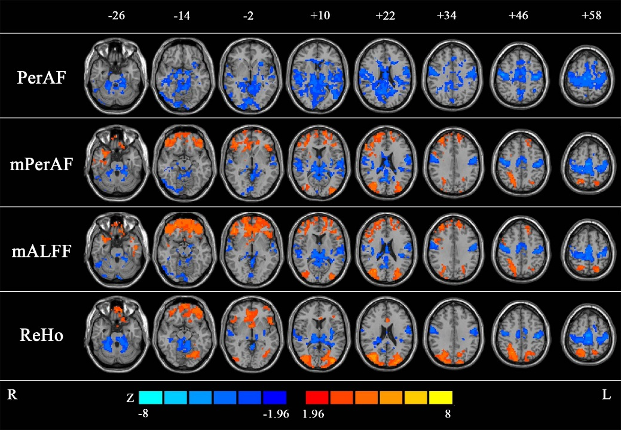

Figure. 1 Results of paired t-test between EO and EC
Reference
Liu, D., Dong, Z., Zuo, X., Wang, J., Zang, Y., 2013. Eyes-open/eyes-closed dataset sharing for reproducibility evaluation of resting state fMRI data analysis methods. Neuroinformatics 11, 469–476. https://doi.org/10.1007/s12021-013-9187-0
Yuan, B.-K., Wang, J., Zang, Y.-F., Liu, D.-Q., 2014. Amplitude differences in high-frequency fMRI signals between eyes open and eyes closed resting states. Front. Hum. Neurosci. 8, 503. https://doi.org/10.3389/fnhum.2014.00503
Zang, Y., Jiang, T., Lu, Y., He, Y., Tian, L., 2004. Regional homogeneity approach to fMRI data analysis. NeuroImage 22, 394–400. https://doi.org/10.1016/j.neuroimage.2003.12.030
Zang, Y.-F., He, Y., Zhu, C.-Z., Cao, Q.-J., Sui, M.-Q., Liang, M., Tian, L.-X., Jiang, T.-Z., Wang, Y.-F., 2007. Altered baseline brain activity in children with ADHD revealed by resting-state functional MRI. Brain Dev. 29, 83–91. https://doi.org/10.1016/j.braindev.2006.07.002
Zou, Q., Yuan, B.-K., Gu, H., Liu, D., Wang, D.J.J., Gao, J.-H., Yang, Y., Zang, Y.-F., 2015. Detecting static and dynamic differences between eyes-closed and eyes-open resting states using ASL and BOLD fMRI. PloS One 10, e0121757. https://doi.org/10.1371/journal.pone.0121757

