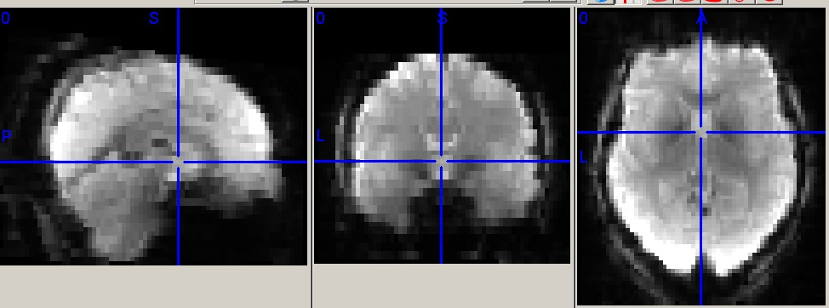
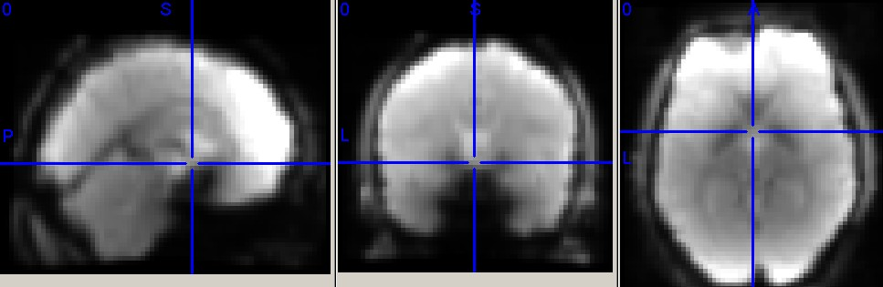
都采用4 mm平滑
DARTEL 配准的静息态功能像 swra* img

Unified segmentation 配准的静息功能像 swra* img

Normalise命令：
Running job #1
-----------------------------------------------------------------------
Running 'Normalise to MNI Space'
** Affine registering "Template_6" with MNI space **
1 5.28419 0.186359
2 3.10261 0.0899961
3 0.98414 0.0512093
4 0.095307 0.0477939
5 0.0130903 0.0478257
6 0.00235347 0.047835
7 0.000363603 0.0478359
8 5.42653e-005 0.047836
** "u_rc1co20100702_124624t1mpragewangyongping3T-018-01as011a1001_Template" **
c1co20100702_124624t1mpragewangyongping3T-018-01as011a1001 1,1,1
c2co20100702_124624t1mpragewangyongping3T-018-01as011a1001 1,1,1
c3co20100702_124624t1mpragewangyongping3T-018-01as011a1001 1,1,1
Done 'Normalise to MNI Space'
Done
Running DARTEL: Normalize to MNI space for VBM. Modulated version.
-----------------------------------------------------------------------
Running job #1
-----------------------------------------------------------------------
Running 'Normalise to MNI Space'
** Affine registering "Template_6" with MNI space **
1 5.28419 0.186359
2 3.10261 0.0899961
3 0.98414 0.0512093
4 0.095307 0.0477939
5 0.0130903 0.0478257
6 0.00235347 0.047835
7 0.000363603 0.0478359
8 5.42653e-005 0.047836
** "u_rc1co20100702_124624t1mpragewangyongping3T-018-01as011a1001_Template" **
c1co20100702_124624t1mpragewangyongping3T-018-01as011a1001 1,1,1
c2co20100702_124624t1mpragewangyongping3T-018-01as011a1001 1,1,1
c3co20100702_124624t1mpragewangyongping3T-018-01as011a1001 1,1,1
Done 'Normalise to MNI Space'
Done
Running DARTEL: Normalize to MNI space for VBM. Unmodulated version.
-----------------------------------------------------------------------
Running job #1
-----------------------------------------------------------------------
Running 'Normalise to MNI Space'
** Affine registering "Template_6" with MNI space **
1 5.28419 0.186359
2 3.10261 0.0899961
3 0.98414 0.0512093
4 0.095307 0.0477939
5 0.0130903 0.0478257
6 0.00235347 0.047835
7 0.000363603 0.0478359
8 5.42653e-005 0.047836
** "u_rc1co20100702_124624t1mpragewangyongping3T-018-01as011a1001_Template" **
c1co20100702_124624t1mpragewangyongping3T-018-01as011a1001 1,1,1
c2co20100702_124624t1mpragewangyongping3T-018-01as011a1001 1,1,1
c3co20100702_124624t1mpragewangyongping3T-018-01as011a1001 1,1,1
co20100702_124624t1mpragewangyongping3T-018-01as011a1001 1,1,1
Done 'Normalise to MNI Space'
Done
Normalization by using DARTEL Setup:Sub_001 OK
-----------------------------------------------------------------------
Running job #1
-----------------------------------------------------------------------
Running 'Normalise to MNI Space'
** Affine registering "Template_6" with MNI space **
1 5.28419 0.186359
2 3.10261 0.0899961
3 0.98414 0.0512093
4 0.095307 0.0477939
5 0.0130903 0.0478257
6 0.00235347 0.047835
7 0.000363603 0.0478359
8 5.42653e-005 0.047836
** "u_rc1co20100702_124624t1mpragewangyongping3T-018-01as011a1001_Template" **
ra20100702_124624ep2dpacedyntmocowangyongping3T-018-01as003a001_051 1,1,1
..............051-210副图像的标准化（省）
ra20100702_124624ep2dpacedyntmocowangyongping3T-018-01as003a001_210 1,1,1
Done 'Normalise to MNI Space'
Done

??? Error using ==> move file
No matching files were found.

Error in ==> DPARSFA_run at 1317
movefile('w*',['..',filesep,'..',filesep,FunSessionPrefixSet{iFunSession},AutoDataProcessParameter.StartingDirName,'W',filesep,AutoDataProcessParameter.SubjectID{i}])

Error in ==> DPARSFA>pushbuttonRun_Callback at 1133
[Error]=DPARSFA_run(handles.Cfg);

Error in ==> gui_mainfcn at 96
feval(varargin{:});

Error in ==> DPARSFA at 31
gui_mainfcn(gui_State, varargin{:});

??? Error while evaluating uicontrol Callback

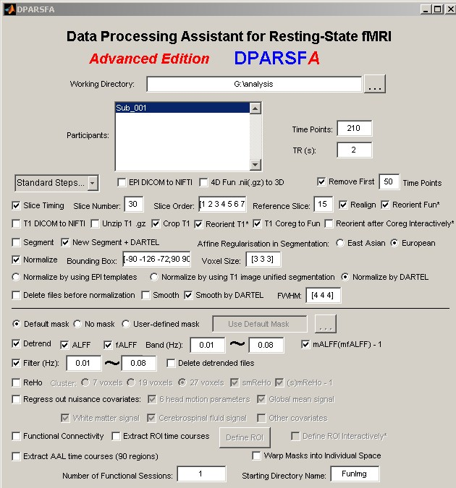
DPARSFA界面设置

