REST Normality Test Read Me
- Introduction
For many studies, the statistic analysis, especially the T tests, have been considered in great significance. It should be emphasized that, for T tests, the sample must be normally distributed, otherwise the results may be incorrect. We implemented REST Normality Test to provide a toolkit for Normality Tests.

- Method
REST Normality Test supports the Jarque-Bera goodness-of-fit test and the Lilliefors goodness-of-fit test. The normality of data with unknown parameter (mean, variance) could be estimated.
2.1 Jarque-Bera goodness-of-fit test
The Jarque-Bera test estimates whether the skewness (S) and kurtosis (K) of the sample matching the normal distribution. The test statistic JB is defined as
$$\text{JB}=\frac{n}{6}\left(S^{2}+\frac{1}{4}(K−3)^{2}\right)$$
where n is the number of sample, S is the skewness and K is the kurtosis.
If the sample comes from a normal distribution, the JB will be asymptotically a 2 degrees of freedom chi-square distribution. It should be noted that the Jarque-Bera test is not suitable for small sample because the chi-squared approximation is overly sensitive and often wrongly reject the null hypothesis that the sample is from a normal distribution.
2.2 Lilliefors goodness-of-fit test
The Lilliefors goodness-of-fit test is an adaptation of the Kolmogorov–Smirnov test. It is used to test whether the sample is from normal distribution with unknown mean and variance.
The null hypothesis of Lilliefors goodness-of-fit test is that the sample is from a normal distribution. The test may reject the null hypothesis that the sample is from a normal distribution only if the P value is less than a threshold.

- Output of REST Normality Test
The output of REST Normality Test is paired img/hdr maps with P value of every voxel. The P value is ranking from 0.001 to 0.5 in REST Normality Test (a default ranking in Matlab). Voxels with P value less than a threshold (0.05, for example) is considered that the sample is not normally distributed. For voxels with P value greater than threshold, we can consider that the sample is normally distributed.
The following figure shows the result maps from REST Normality Test:
Sample (Shang et al., 2011 poster #D02):
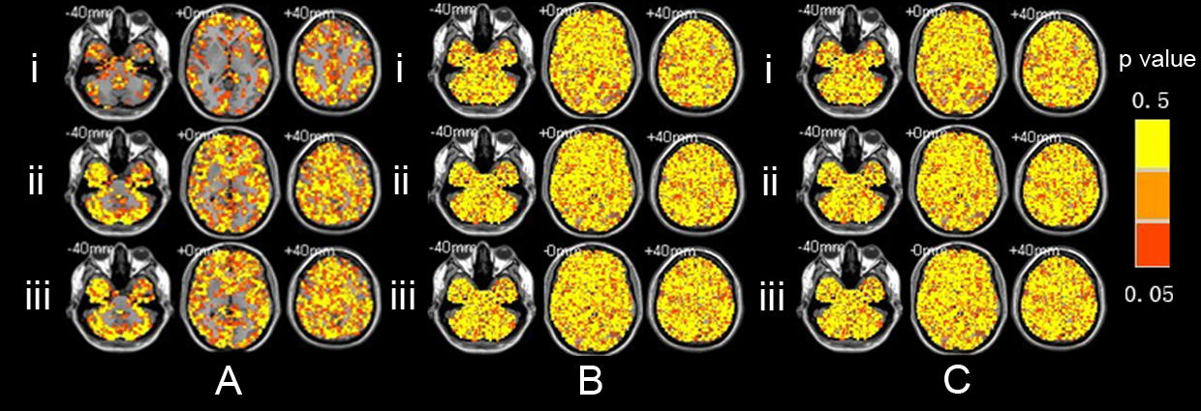
The results of Lilliefors test on ALFF (Ai), mALFF (Aii), zALFF (Aiii), fALFF (Bi), mfALFF (Bii), zfALFF (Biii), ReHo (Ci), mReHo (Cii) and zReHo (Ciii). The left of the figure is the right of the brain.

